Agile Processes
Agile is a software development methodology to build a software incrementally using short iterations of 1 to 4 weeks so that the development process and testing happens parallel
Agile is incremental & iterations process where development & testing activity happens parallel
Types of Agile Processes
1 . Agile SCRUM methodology
2. Extreme Programing
3. Kanban processes
4.Crystal
5. Lean software development

Agile SCRUM Methodology

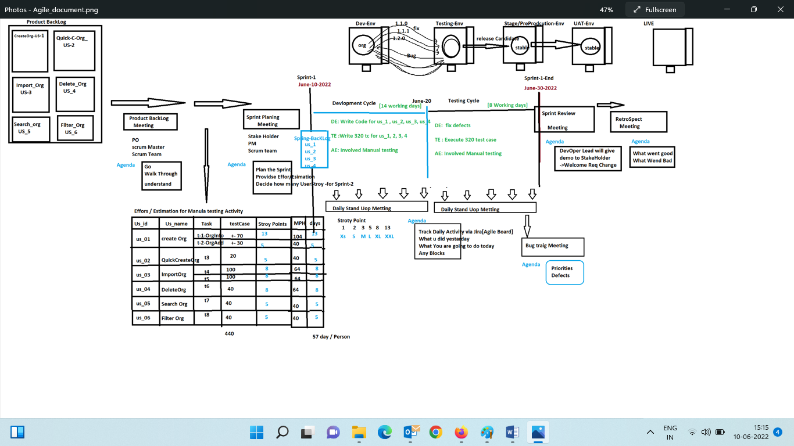
Scrum is a lightweight Agile project management framework that can be used to manage iterative and incremental projects , where development & testing activity happens parallel

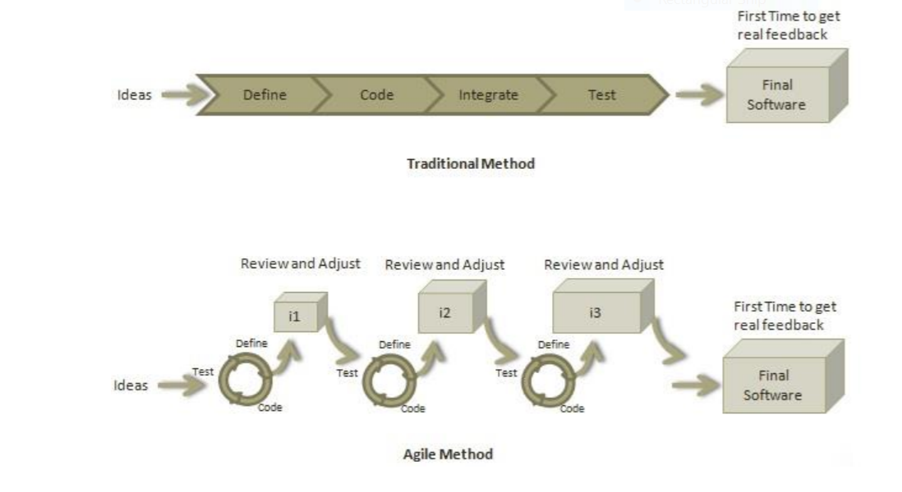

12 Principles Behind the Agile Manifesto

1. Customer Satisfaction - Highest priority is given to satisfy the requirements of customers through early and continuous delivery of valuable software.
2. Welcome Change - Changes are inevitable during software development. Everchanging requirements should be welcome, even late in the development phase. Agile processes should work to increase customers' competitive advantage.
3. Deliver a Working Software - Deliver a working software frequently, ranging from a few weeks to a few months, considering shorter time-scale.
4. Collaboration - Business people and developers must work together during the entire life of a project.
5. Motivation - Projects should be built around motivated individuals. Provide an environment to support individual team members and trust them so as to make them feel responsible to get the job done.
6. Face-to-face Conversation - Face-to-face conversation is the most efficient and effective method of conveying information to and within a development team.
7. Measure the Progress as per the Working Software - Working software is the key and it should be the primary measure of progress.
8 Responding to change over Following a plan That is, while there is value in the items on the right, we value the items on the left more. Agile 6
9. Monitoring - Pay regular attention to technical excellence and good design to enhance agility.
10. Simplicity - Keep things simple and use simple terms to measure the work that is not completed.
12. Review the Work Regularly - Review the work done at regular intervals 12 Customer involved in Testing activity

Agile Team /Scrum Team

Scrum Master
A Scrum Master is a team leader and facilitator who helps the team members to follow agile practices so that they can meet their commitments.
The responsibilities of a scrum master are as follows:
• To enable close co-operation between all roles and functions.
• To remove any blocks
• To work with the organization to track the progress and processes of the company.
• Scrum Master handle the Daily standup meeting

Product Owner
A Product Owner is the one who drives the product from business perspective. The responsibilities or a Product Owner are as follows:
• To define the requirements and prioritize their values
• To determine the release date and contents.
• To take an active role in iteration planning and release planning meetings.
• To ensure that team is working on the most valued requirement.
• To represent the voice of the customer.
• To accept the user stories that meet the definition

Stakeholder
is anyone that is potentially affected by the outcome of the project. The term is usually used to name the management or the customers.
Stakeholders are a customer representative who facilitate the requirement from the Customer side ,
Is a program managers, subject matter experts act as advisers as decisions are made around the release planning.

Development Scrum team
Development Scrum team will take care of development activity
Manual Testing Scrum Team
Manual Scrum team will take care manual testing activity
Automation Scrum Team
Take care of handling automation scrum activity
DevOps Scrum Team
Take Care of Build management
.===================================================================================

Sprint
(fixed duration of time from define the requirement design test deliver the shippable final candidate )
The Project divided sprints , each sprint will have specified time line (2 week to 1 month or 3 month), the end result of each sprint should be shippable product

Product Backlog
It’s a Repository (Git Hub) where all the List of UserStory Are stored and maintained by the product owner
Set of functional and non-functional product requirements repository which is maintained by product owner

Sprint backlog
List of User Stories committed for the particular Sprint
User Story
It’s a customer requirement to fulfill end user requirement. It is normally written from the perspective of an end-user.
Story Points
It’s a define the effort & priority taken for each user stories , its helps us for estimation
In most cases a story point uses one of the following scales for sizing:
• 1,2,4,8,16
• X-Small, Small, Medium, Large, Extra-Large , XXL
• Fibonacci sequence: 1,2,3,5,8,13,2
1 story points effort is 8 mph[man per hour] in service base company
1 story points effort is 6 mph[man per hour] in product base company

Capacity
Capacity defines how much an individual can commit. Capacity is estimated in hours

Velocity
A measure to weight the accepted work in an iteration or timebox
Acceptance Criteria
It is the conditions set by the product owner or the customer in order to accept a feature to be valid and adhering to their requirements.
- Within 15 days of Sprint Review meeting , if customer didn’t come back with defects , it means product is accepted by Customers
- We have to submit execution reports to customers after every Sprint
- We have to submit bug reports to customers after every Sprint
- We have to submit updated test case after every Sprint
- Should not have critical defects
- Release candidates should have release notes /change logs
Burn Up cart
burn up shows how much work has been completed, and the total amount of work.
Burn Down Cart
A burn down chart shows how much work is remaining to be done in the project

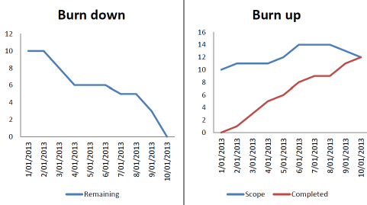

=================================================================================
Sprint Grooming meeting
Product team review the Backlogs items and decide on the number of user stories taken for the sprint
Grooming (or refinement) is a meeting of the Scrum team in which the product backlog items are discussed and the next sprint planning is prepared.
Sprint planning meetings (meeting handled by PO)
Where entire scrum attends , , here is the product owner select the list of userStory based on priority or story Point , then they will create SPINT Backlog
What is Daily Stand-up?
• A daily stand-up is a daily status meeting among all team members and it is held roughly for 15 minutes. It brings everyone up to date on the information and help the team to stay organized
. what he.she did yesterday
. any blocks
. what you will do today
Bug traig meeting
Talk to development team to priorities the defects
Sprint Review meetings
Scrum development team present a demonstration of a stable release candidates product . product owner declare which itsem is completed & not completed , product owner might add addition requirement based on stakeholder feedback

Retrospect meetings
Scrum team meet again after the Sprint review meeting and document the lesson learnt in previous
Release
What went good
What went wrong

Advantages of Agile Processes
- Stakeholder Engagement. ...
- Transparency. ...
- Early and Predictable Delivery. ...
- Predictable Costs and Schedule. ...
- Allows for Change. ...
- Focuses on Business Value. ...
- Focuses on Users. ...
- Improves Quality.
- Customer involved in testing activity
- Customer know what we going to deliver
Interview Questions
  - Which processes, you fallowed in your previous organization. ?
  - Explain which methodology you fallowed in Agile ?
  - Explain principles/ Advantages of Agile ?
  - What is capacity & velocity in Agile ?
  - What is Burn-down &Burn-up cart in Agile ?
  - Explain the meetings in Agile ?
  - What discussion happens in Retrospect meeting?
  - Roles of stake holder & scrum master & Product owner in Agile ?
  - What is Story Points?
  - Explain Agile Processes?
Explain Agile
Definition of Agile + participants of Agile + Product Backlog[Jira] +Product Backlog Meeting+ Effort & estimation + SPRINT Planning Meeting + Sprint Backlog + Activities of testing & development cycle + Bug Traig meeting + Sprint Review Meeting + move To UAT + SPRINT Retrospect meeting Agile Advantages

